GUIDE FOR PROPER PROGRAMMING TECHNIQUES

GENERAL

* Keep programs and methods short and manageable
* Use straightforward logic and flow-of-control (if statements, for loops, etc.)
* Avoid magic numbers – give them meaningful names
* One statement per line

NAMING CONVENTIONS

* Use meaningful names
* Be consistent
* Use more descriptive names for important variables
* Use short names for short-lived variables or loop-index variables

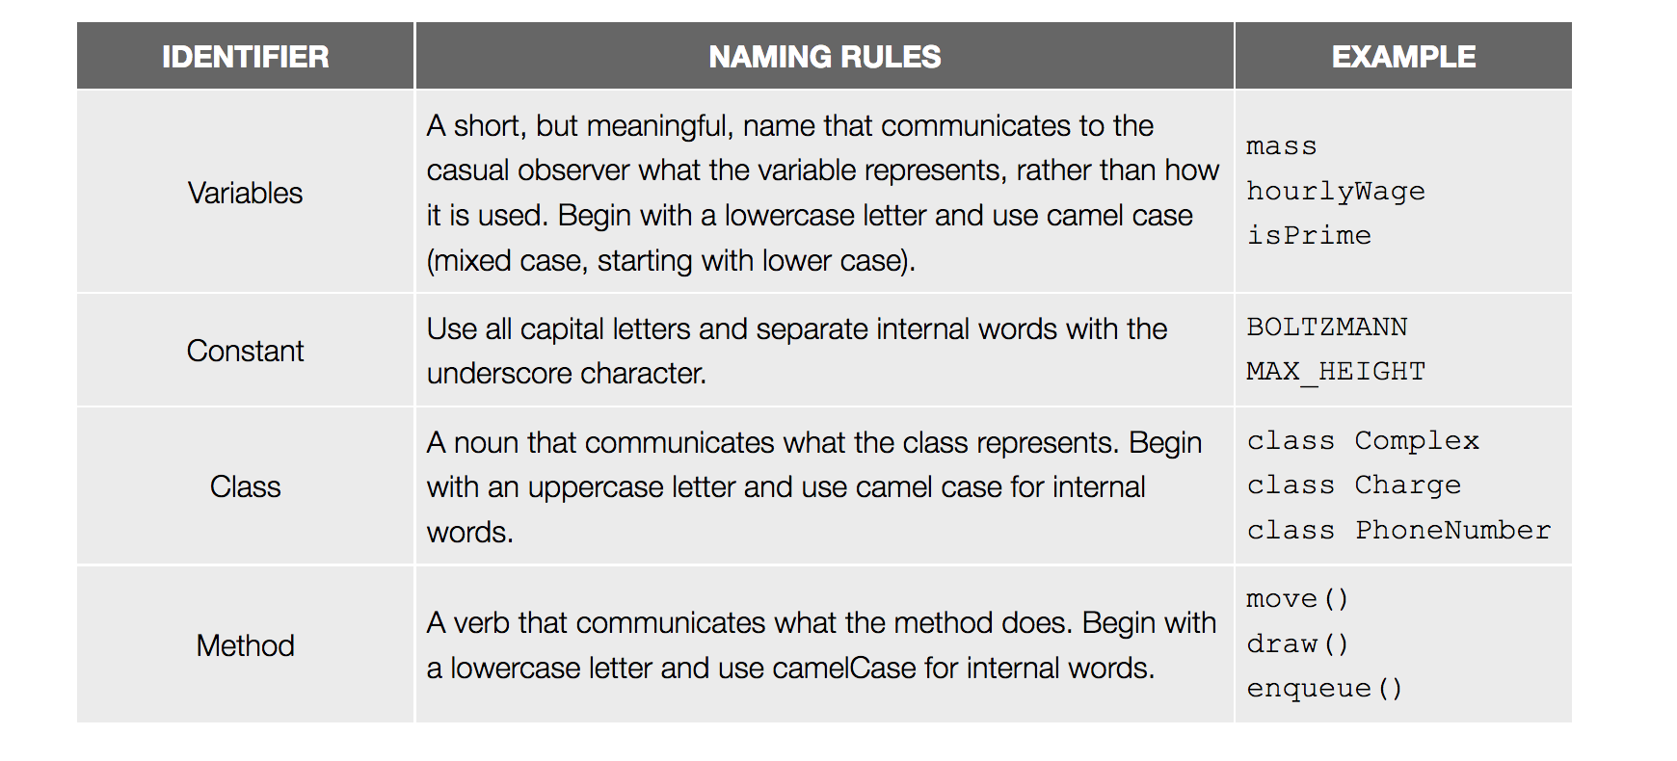

COMMENTING

* Use // for line comments for short one-line comments (like describing variable initializations). Line comments can only span one line.
* Use /\* to begin a block comment and \*/ to end one. Block commends can span multiple lines.
* Make sure comments correspond correctly to code. Do not put comments in order to explain bad code! Just fix the code.
* Include a block comment at the beginning of a program for author name, date, name of program and program’s purpose.
* Comment each method with a description of what it does – reference the parameters by name in your description.
* Do not write comments that merely restate the code. Comments should describe *what* or *why* you are doing something, not *how*.

WHITESPACE

* Use blank lines to separate code into logical sections.
* Put a space: between operators and their operands (+, -, <=), between keyword and its opening parenthesis (for, while, if), between statements in for loop, around equals sign.
* Do not put a space: before the semicolon, between method name and its left parenthesis.

INDENTATION

* Indent based on the level of nesting (i.e. all classes are indented to the same level, all methods are indented to the same level.)